(It is advised to not use this technique, rather pass data using models)

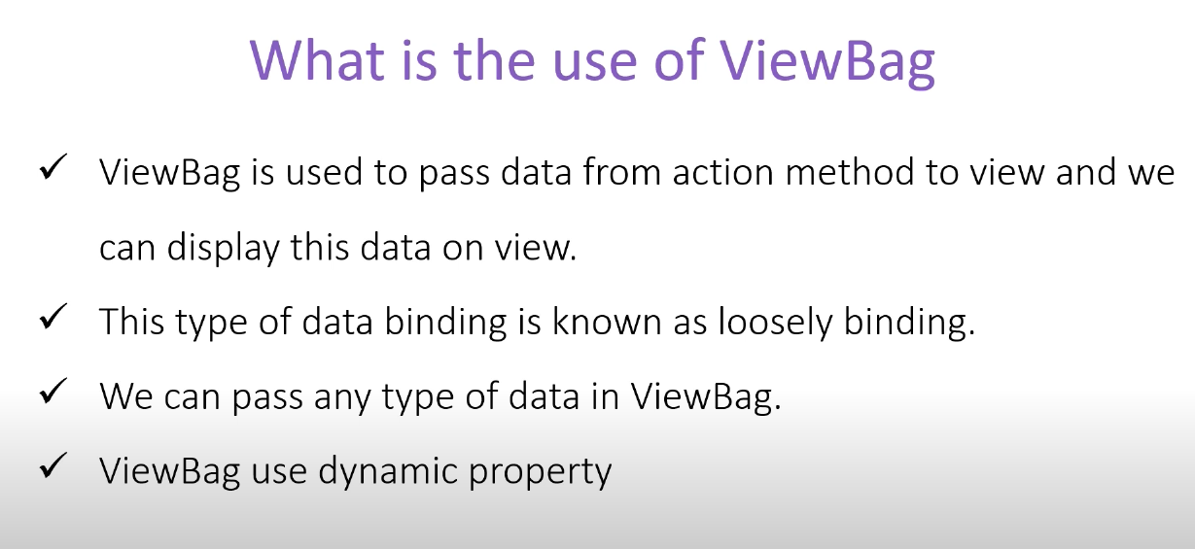

* Difference between loosely binding and strongly binding? (Google it)

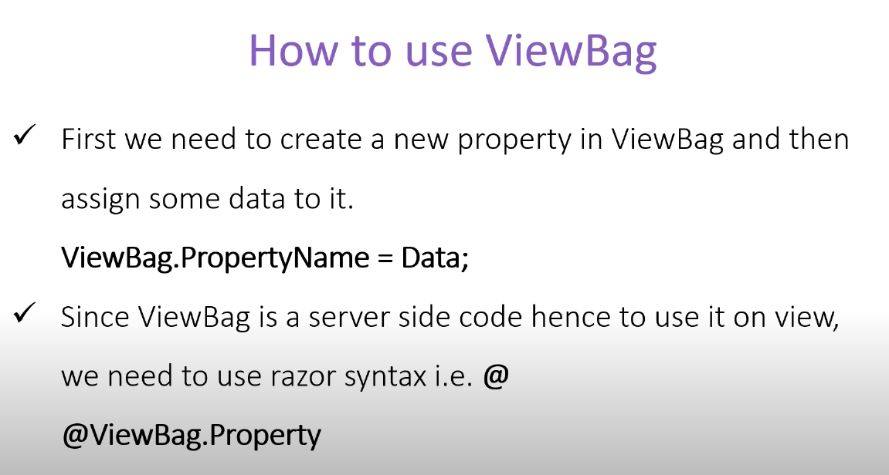

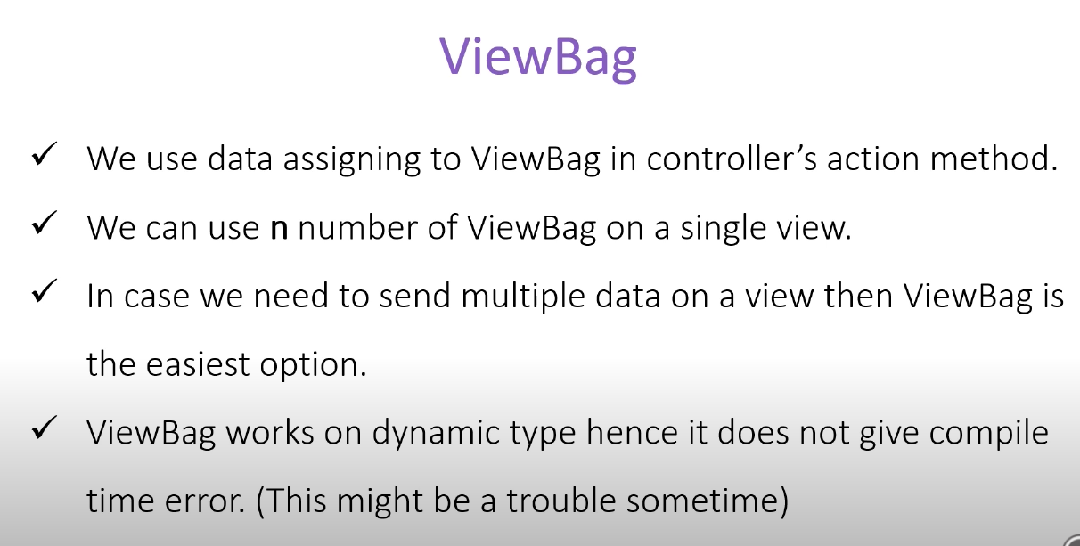

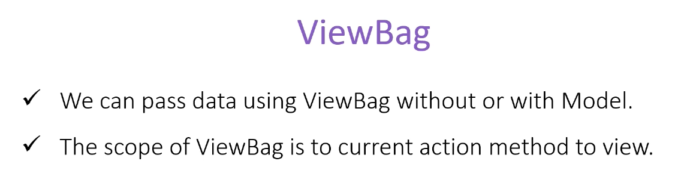

To pass an anonymous object we get a bit complication, we run into error if we try to access the property of the object. To fix this we can use the following technique.

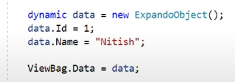

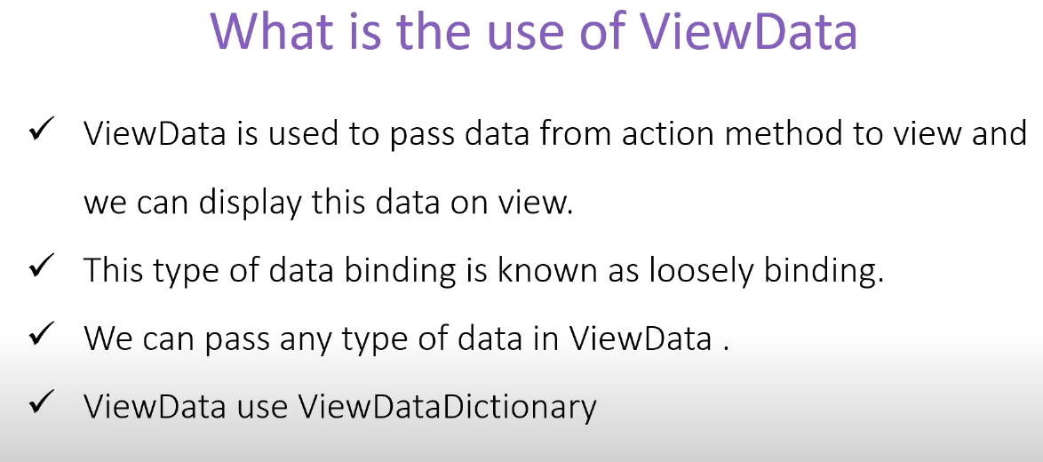

As we can see, the main difference between viewdata and viewbag is the type, viewdata is dictonary/hash type (key/value pair) while viewbag is dynamic type.

For this reason, viewdata is a bit faster than viewbag.

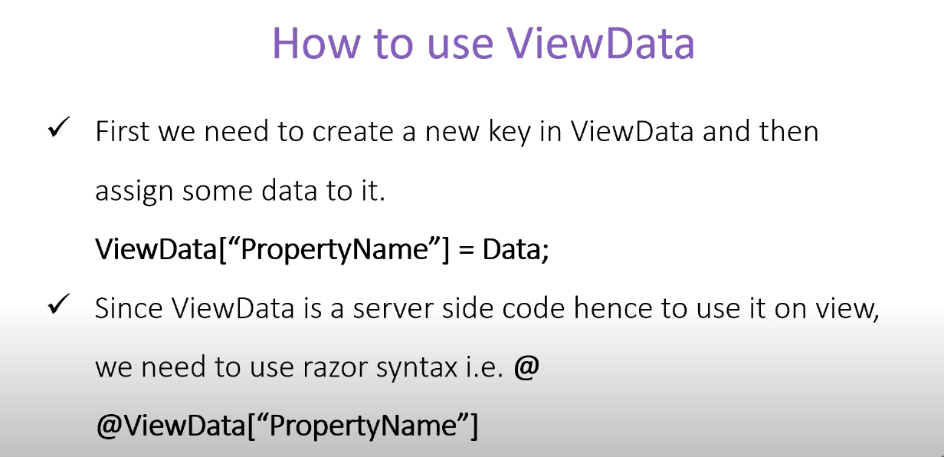

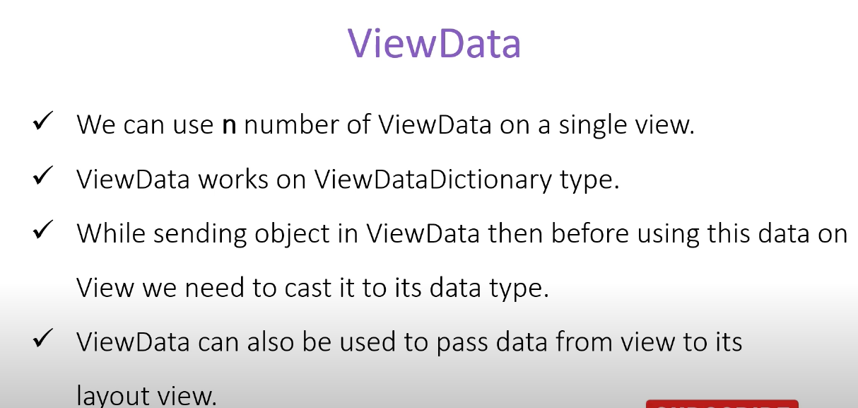

We need cast the viewdata to its data type inside the view before actually using it, otherwise we will get an error. Cause when we send the viewdata containing an object it goes to view as a generic type (if we point mouse over visual studio, we can see this).

We can use this technique to set the page title etc. dynamically.

ViewData Attribute

This is similar to the viewdata, but a different technique. We use attribute to a property to declare it as a ViewData. In this case we can directly set the data from the controller even.

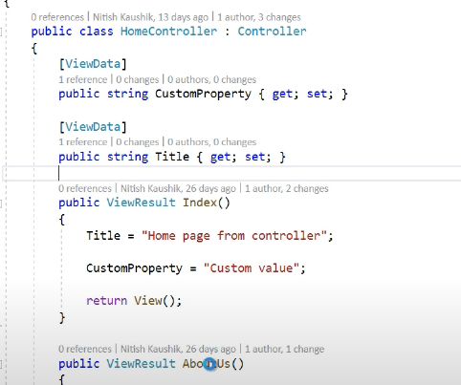

Here we can see, we set the title in the controller class. In this way we don’t need to define the title manually in the viewpage.

We can also overwrite this data inside the viewpage, in case we want to change it.